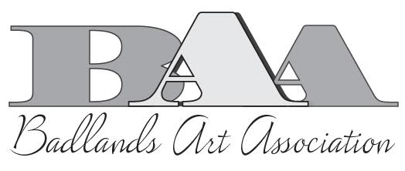
Badlands Art Show – Student Entry
Due October 31, 2019
Add mat and wire hanger to any pieces to be hung.
Complete the 2 registration sections below for each entry: one to be submitted for our records & one attached to the art piece that is deliver to the show.
Add $1.00 check payable to Badlands Art Association or cash in an envelope, with student first & last name, class, teacher initial and school on the envelope. Homeschool students mail in their entry form to BAA, PO Box 502, Dickinson, ND 58601.
Student Registration Form
Student Name _______________________________________________ Age _______
First and Last Name

School ____________________________ Grade ______ – _________ (Teacher, example: 2-T)

Medium or Category: Circle one
Drawing Painting Printmaking Sculpture Craft Mixed Media

Title of Work ____________________________________________________________________

Student Registration Form (Remove & attach securely to the back of the artwork as directed below)
Student Name _______________________________________________ Age _______
First and Last Name

School ____________________________ Grade ______ – _________ (Teacher, example: 2-T)

Medium or Category: Circle one
Drawing Painting Printmaking Sculpture Craft Mixed Media

Title of Work ___________________________________________________________________

Each work must be matted and labeled with one entry form taped to the back lower right corner.
Please tape an envelope to the back – lower left corner, and include the entry fee, other registration form, and seal the envelope. Please copy more entry forms if you are entering more than one work of art.

